JSON Errors & Debugging

🌟 What is this topic about?
# Source: AI Source: Provided by: [Data Path: Persons Table -> ID Column: 1, Name_En Column: Motasem Essam] -> From: [ChatGPT] on [5/31/2026]
This topic explains common mistakes in JSON and how to find and fix errors when JSON is invalid or not working.

⚠️ common mistakes

❌ 1. Missing Double Quotes
# Source: AI Source: Provided by: [Data Path: Persons Table -> ID Column: 1, Name_En Column: Motasem Essam] -> From: [ChatGPT] on [5/31/2026]
🌟 Problem
Keys or strings not using double quotes.
📦 Wrong:
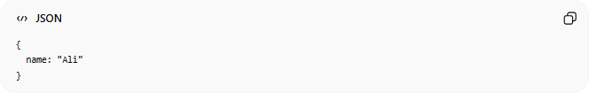
{
name: "Ali"
}
✅ Correct:
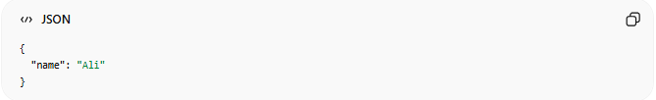
{
"name": "Ali"
}

❌ 2. Trailing Commas
# Source: AI Source: Provided by: [Data Path: Persons Table -> ID Column: 1, Name_En Column: Motasem Essam] -> From: [ChatGPT] on [5/31/2026]
🌟 Problem
Extra comma at the end.
📦 Wrong:
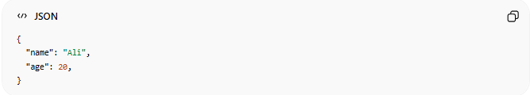
{
"name": "Ali",
"age": 20,
}
✅ Correct:
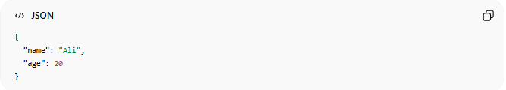
{
"name": "Ali",
"age": 20
}

❌ 3. Using Single Quotes
# Source: AI Source: Provided by: [Data Path: Persons Table -> ID Column: 1, Name_En Column: Motasem Essam] -> From: [ChatGPT] on [5/31/2026]
🌟 Problem
JSON does NOT allow single quotes.
📦 Wrong:
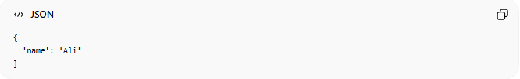
{
'name': 'Ali'
}
✅ Correct:
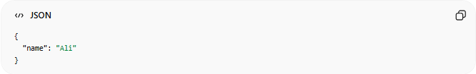
{
"name": "Ali"
}

❌ 4. Invalid Structure
# Source: AI Source: Provided by: [Data Path: Persons Table -> ID Column: 1, Name_En Column: Motasem Essam] -> From: [ChatGPT] on [5/31/2026]
🌟 Problem
JSON must be properly structured.
📦 Wrong:
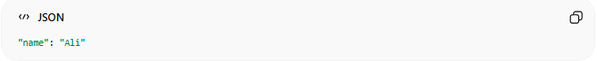
"name": "Ali"
✅ Correct:
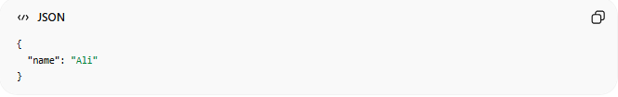
{
"name": "Ali"
}

❌ 5. Using Comments (Not Allowed)
# Source: AI Source: Provided by: [Data Path: Persons Table -> ID Column: 1, Name_En Column: Motasem Essam] -> From: [ChatGPT] on [5/31/2026]
📦 Wrong:
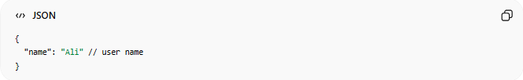
{
"name": "Ali" // user name
}

❌ 6. Undefined or Functions
# Source: AI Source: Provided by: [Data Path: Persons Table -> ID Column: 1, Name_En Column: Motasem Essam] -> From: [ChatGPT] on [5/31/2026]
JSON does NOT support functions or undefined values.

🔍 How to Debug JSON
# Source: AI Source: Provided by: [Data Path: Persons Table -> ID Column: 1, Name_En Column: Motasem Essam] -> From: [ChatGPT] on [5/31/2026]
🧰 Tools:
- JSON validators
- Browser DevTools
- Postman
- Online formatters
Example tool:
JSONLint Validator

⚙️ Debugging Process
# Source: AI Source: Provided by: [Data Path: Persons Table -> ID Column: 1, Name_En Column: Motasem Essam] -> From: [ChatGPT] on [5/31/2026]
Write JSON → Validate → Find error → Fix → Test again

🧠 Simple Idea
# Source: AI Source: Provided by: [Data Path: Persons Table -> ID Column: 1, Name_En Column: Motasem Essam] -> From: [ChatGPT] on [5/31/2026]
Think of JSON like:
📦 A strict delivery system
- If label is wrong → package is rejected 🚫
- If format is correct → package is accepted ✅

⚠️ Most Common Errors Summary
# Source: AI Source: Provided by: [Data Path: Persons Table -> ID Column: 1, Name_En Column: Motasem Essam] -> From: [ChatGPT] on [5/31/2026]
- Missing quotes
- Extra commas
- Wrong brackets
- Invalid structure
- Unsupported features

🧭 Summary
# Source: AI Source: Provided by: [Data Path: Persons Table -> ID Column: 1, Name_En Column: Motasem Essam] -> From: [ChatGPT] on [5/31/2026]
JSON errors happen when data does not follow strict formatting rules. Debugging means finding and fixing syntax issues so the JSON becomes valid and usable in applications and APIs.

